**Higher Colleges of Technology**

**EGN 2712: Applied Programing for Engineers**

PROJECT WORK

TITLED:

**MATLAB PROGRAM TO DETERMINE**

**RESISTANCE OF A FOUR BANDS COLOR-CODED RESISTOR**

**Submitted By:**

|  |  |  |
| --- | --- | --- |
|  | **Member Names:** | **Member ID** |
|  |  |  |

***SUBMITTED ON***

***__________***

***GENERAL INFORMATION AND GUIDE***

1. **General info**

* Direct copy of work will be highly penalized. (-10%).
* You are advised to follow the guide provided below for smooth and timely completion of the work.
* The report should be prepared in line with format provided in section C.

Apart from that: use 12 points, Time New Roman Normal fonts for the body of the report, and 14 points, Time New Roman Bold fonts for all section heads; and double spacing.

* Deadline for submission and presentation is **Week 14th of the Semester.**
* Each one would submit the following:

i. Report according to the format specified

ii. Softcopy of the codes (.m file)

ii. Demonstration of the program functionality with three difference resistors.

1. **Tasks and Guide**

1. Problem statement:

Write a MATLAB program that calculates resistance of a resistor from the color code.

The standard four band resistor color code is given in the table below

**RESISTOR COLOR CODE CHART**

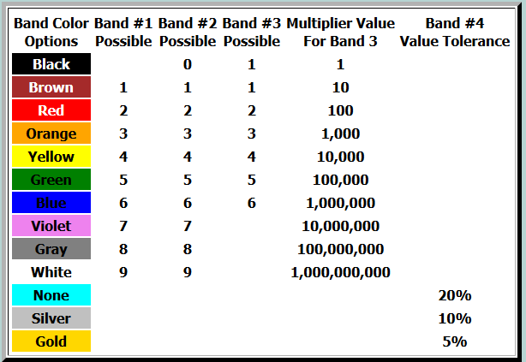

**2. Here is example of input/output dialog**

**Enter Band 1 Color: brown**

**Enter Band 2 Color : black**

**Enter Band 3 Color : red**

**Enter Band 4 Color : silver**

**Resistance Value is : 1000 Ohms**

**Resistance Value range is: 900 to 1100 Ohms**

**3. Main Tasks:**

* **Read and understand the problem statement**
* **Formulate the algorithm using pseudocode and top-down stepwise refinement.**
* **Draw flowchart**
* **Write a MATLAB program**
* **Test, debug and execute the program**
* **Prepare report and Poster**

**4. Assessment Strategy/Rubrics:**

Report (10%)

Presentation and oral viva(20%)

1. **Report format**
2. **Title page** : as indicated in this Guide
3. **Introduction**

Hint: include purpose of the project and it is important to the course, your understanding resistor color codes and application in electronics and electrical engineering.

1. **Project Objective**

Hint: simply state the objective of this project

1. **Methodology**

Hints: mention the main steps you are to use in the carrying out the projects

1. **Algorithm Development**

Hint: report your pseudocode and flowchart for the problem.

1. **C-Program**

Hint: report the full MATLAB-codes you developed for the problem.

1. **Testing and Results**

Hint: report results of at least three resistors (get the resistors from the technician). Make sure to sketch the diagram of the resistors you use

1. **Conclusion**

Hint: comment on your achievement in this project. Briefly state your view about what you have learnt in this project with respect to the computer programming course.

1. **References**

List any materials you use in this project including lecture slides, textbook, and websites.